|  |  |  |
| --- | --- | --- |
| May 4  2015 | IndusInd Bank Mobile Application | |
| **Functional Specifications Document** | |  |

 

**Account Summary, Details, Inquiry**

**Version 4.0**

**© Copyright. Kony Solutions, 2011. All rights reserved.**

*This manual contains proprietary information, which is protected by copyright. The information in this manual is furnished under a software license or non-disclosure agreement. The information may be used or copied only in accordance with the terms of the applicable agreement. No part of this manual may be reproduced or transmitted in any form or by any means, electronic or mechanical, including photocopying and recording for any purpose other than the purchaser's personal use without the written permission of Kony Solutions.*

**Document Revision History**

**Revision History**

|  |  |  |  |
| --- | --- | --- | --- |
| Date | Description | Version | Revised by |
| 22-Mar-2015 | Initial Draft | 1.0 | Krishnakanth |
| 06-Apr-2015 | Updated after first review | 2.0 | Krishnakanth |
| 17-Apr-2015 | Updated after second review | 3.0 | Krishnakanth |
| 04-May-2015 | Updated after third review | 4.0 | Krishnakanth |
|  |  |  |  |
|  |  |  |  |
|  |  |  |  |

|  |  |  |  |
| --- | --- | --- | --- |
| **Process / Document Owner** |  | | |
| Document ID | **IndusInd Mobile App – Account Summary – Functional Spec** | **Version** | **4.0** |
|  | Name | Date | Signature |
| Approved by |  |  |  |
| Reviewed by |  |  |  |
| Prepared by | **Krishnakanth** |  |  |

**Open Items, Issues and Gaps**

|  |  |  |  |  |  |  |
| --- | --- | --- | --- | --- | --- | --- |
| ID | Issue Description | Raised by | Date Raised | Current Status | Closure Date | Owners & Remarks |
|  |  |  |  |  |  |  |
|  |  |  |  |  |  |  |
|  |  |  |  |  |  |  |
|  |  |  |  |  |  |  |
|  |  |  |  |  |  |  |
|  |  |  |  |  |  |  |
|  |  |  |  |  |  |  |

**Reference Materials**

|  |  |  |  |
| --- | --- | --- | --- |
| Document | Ver. | Document Use | SharePoint Link |
| Account Overview and Account Inquiry Screens.pptx |  | Sample Screenshots |  |
| RD_Mobile_Banking_Account_Summary_Overview_V1.0.docx | 1.0 | BRD |  |
| RD_Mobile_Banking_Account_Summary_Overview_V2 0.docx | 2.0 | BRD |  |
| RD_Mobile_Banking_Account_Summary_Overview_V3 0.docx | 3.0 | BRD |  |
|  |  |  |  |
|  |  |  |  |
|  |  |  |  |
|  |  |  |  |

Table of Contents

1. Account Summary 6

1.1. Wireframe 6

1.2. Widgets Overview 6

2. Account Details 10

2.1. Wireframe 10

2.2. Widgets Overview 11

3. Account Inquiry - Grid View 14

3.1. Wireframe 14

3.2. Widgets Overview 14

3.3. Custom-Fetch 17

3.3.1. State1 17

3.4. dp-Tagging 18

3.4.1. State1 18

4. Account Inquiry - Calendar View 19

4.1. Wireframe 19

4.2. Widgets Overview 20

5. Account Inquiry - Chart View 22

5.1. Wireframe 22

5.2. Widgets Overview 22

# Account Summary

Page Overview

This is the account overview page which displays assets and liabilities as two different tabs. This page will show total assets/liabilities and individual asset / liability types based on the tab that was tapped. There will also be a placeholder (icons/image/button) for Payment/Transfer.

## Wireframe

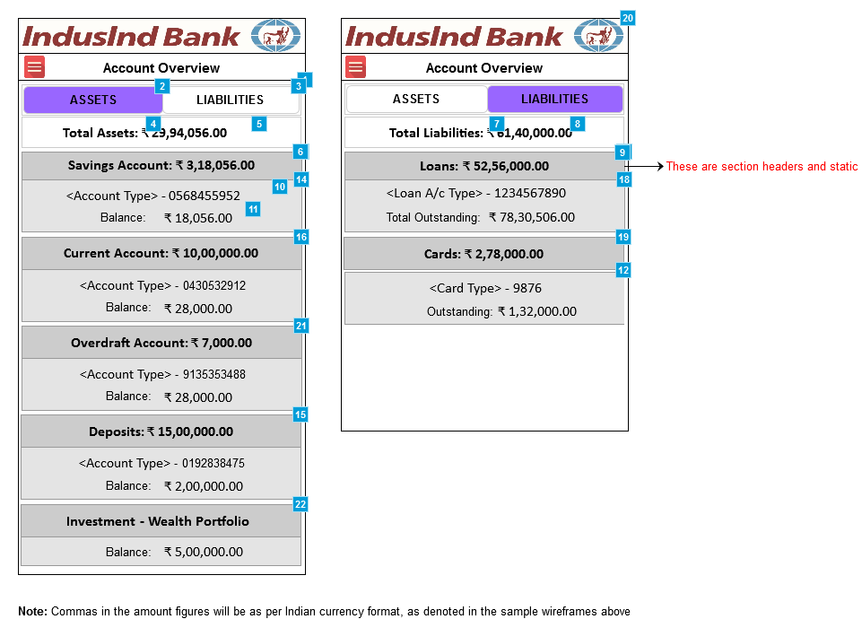

## Widgets Overview

| # | Item Name | Kony Widget Type | Description | Validation Rules | Action | Mandatory? |
| --- | --- | --- | --- | --- | --- | --- |
| 1 | Account Overview - Assets Tab | Form | Account Overview page - Assets Tab selected. All the assets and their available balances will be displayed as received from the backend and will be categorized based on the account types.  The order of categorization will be as received from the response. If there is no order is defined then it should follow the order listed below:  1. Savings Account  2. Current Account  3. Overdraft Account  4. Deposits |  | Will be defined by MSF team |  |
| 2 | Assets tab | Tab | Assets tab that will display all that the customer owns. There will be a flag passed from the backend which will determine if the account type falls into 'assets' or 'liabilities' |  | Tapping will display only the assets |  |
| 3 | Liabilities tab | Tab | Liabilities tab that will display only what the customers owes to the bank. There will be a flag passed from the backend which will determine if the account type falls into 'assets' or 'liabilities' |  | Tapping will display only the liabilities |  |
| 4 | Total Assets label | Label | Total Assets label |  |  |  |
| 5 | Total Assets value | Label | Total Assets value in rupee. This is also called as "Wealth" of the customer. This is the summation of all the available balance amounts of savings, deposits and investment account types. |  |  |  |
| 6 | Individual Assets | Segment | - Individual Assets grouped by asset type. - There will be a flag passed from the backend which will determine if the account type falls into 'assets' or 'liabilities' - Incase for example if the customer does not have an asset type (say Current Account) then the whole section will not be displayed. - If there are multiple accounts for a section (say Savings), then the sequence of listing will be as received from the backend. |  | Tapping will take to Account Details page for the tapped asset type |  |
| 7 | Total Liabilities label | Label | Total Liabilities label |  |  |  |
| 8 | Total Liabilities value | Label | Total Liabilities value - This is the summation of all the total outstanding balance amounts of Loan, Credit Cards etc. |  |  |  |
| 9 | Individual Liabilities | Segment | Individual liabilities grouped by liability type |  | Tapping will take to Account Enquiry page for the tapped liability type |  |
| 10 | Account Type and number | Label | Account Type and number | Account number should not be masked |  |  |
| 11 | Balance Amount | Label | Available Balance for the asset type. This could be negative for current and OD accounts |  |  |  |
| 12 | Credit Cards section | HBox | Credit Cards section - will display the credit card (account) type, last 4-digits of the card number and outstanding balance |  |  |  |
| 13 | Savings Account header | HBox | Savings Account header - Will show the summation of all savings account's balance in case of multiple savings accounts | Static header |  |  |
| 14 | Individual Savings Account summary | HBox | Individual Savings Account summary. Will display the product type, account number and available balance |  | Will be defined by MSF team |  |
| 15 | Deposits header | HBox | Deposits header - will contain all fixed and recurring deposit accounts. Shows the summation of all FD, RD account balances |  |  |  |
| 16 | Current Account header | HBox | Current Account header - Will show the summation of all current account's balance in case of multiple current accounts |  |  |  |
| 17 | Loans header | Segment | Loans header - shows the summation of outstanding amount of all loans |  |  |  |
| 18 | Loans section | HBox | Loans section - will display loan type and loan account number and total outstanding amount |  | Tapping will navigate to account details page |  |
| 19 | Credit Cards header | HBox | Credit Cards header - shows the summation of outstanding balances of all credit cards of the customer |  |  |  |
| 20 | Account Overview - Liabilities Tab | Label | Account Overview page - Liabilities Tab selected. All the liabilities and their total outstanding balances will be displayed as received from the backend and will be categorized based on the account types.  The order of categorization will be as received from the response. If there is no order is defined then it should follow the order listed below:  1. Loans 2. Cards |  | Will be defined by MSF team |  |
| 21 | Current Account header | HBox | Current Account header - Will show the summation of all current account's balance in case of multiple current accounts |  |  |  |
| 22 | Wealth Portfolio header | HBox | Wealth Portfolio header |  | This segment will not be tap-able |  |

Pre-condition

This page can be reached from app menu.

Use Case - Main Flow

1. Customer can do a swipe on a particular account under the section to slide to view a quick summary of other accounts (ex: swiping on Classic Savings - 10488952, will slide and display the next savings account summary will get displayed, if available); same applies for all the accounts, either asset or a liability.

2. Customer can tap on any of the individual asset/liability type to view the account details for that particular account type.

3. Customer can switch between ASSETS and LIABILITIES by tapping on respective tabs.

4. If the customer taps on device back button then the app session will be expired and customer has to login again.

Business Rules

1. Should display the total assets/liabilities along with individual balances/due.

2. The fields displayed on the overview page will be as below:

Savings Account: Account Type, Account Number, Account Balance

Current Account: Account Type, Account Number, Account Balance

Deposits: Cumulative Total

Fixed Deposits: Account Type, Account Number, Account Balance

Recurring Deposits: Account Type, Account Number, Account Balance

Wealth: Wealth Portfolio Account, Balance

Credit Cards: Card Type, Card Number, Total Outstanding

Loans: Card Type, Card Number, Total Outstanding

3. All the account number of assets/liabilities will be displayed fully without masking

4. For credit cards, only the last 4-digits will be displayed

5. All the amount values should be pre-fixed with Indian currency symbol.

6. Negative amount will be pre-fixed with minus (-) sign.

7. By default ASSETS tab should be displayed

8. For card-only customers, LIABILITIES tab will be displayed by default and ASSETS tab should appear disabled.

9. All fields except summation of total assets, liabilities and total of each product type (header) all other fields to be displayed as-is from host file

10. Commas in the amount will be as per the indian currency format

Error Scenarios

1. For some reason if the app-server is down, the customers will see appropriate message saying "There are no Assets to display" instead of the account enquiry.

2. In case if there are no liabilities associated with the customer, then the LIABILITIES tab will appear disabled.

# Account Details

Page Overview

Tapping on any of the assets / liabilities section from account overview page will bring the customer to account details page where the customer will get a detailed picture about the account.

## Wireframe

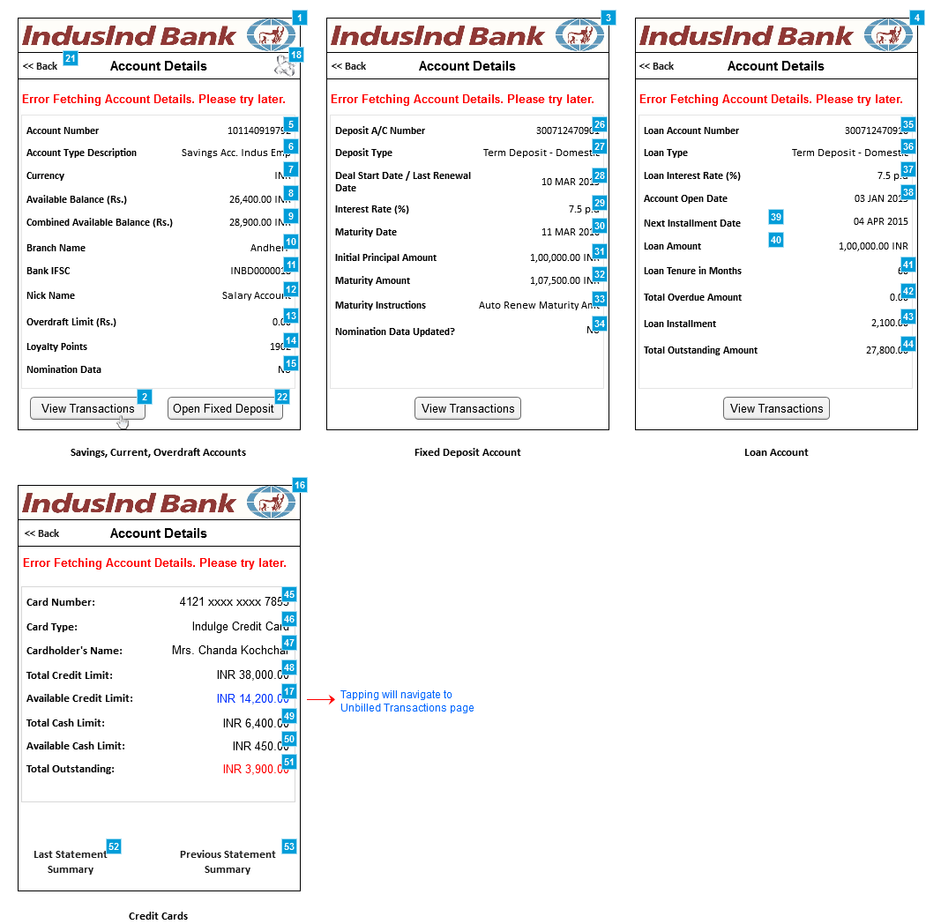

## Widgets Overview

| # | Item Name | Kony Widget Type | Description | Validation Rules | Action | Mandatory? |
| --- | --- | --- | --- | --- | --- | --- |
| 1 | Account Details | Form | Account Details page |  |  |  |
| 2 | View Transactions button | Button | View Transactions button |  | Tapping will take to Transaction Details page for that account type |  |
| 3 | Account Details | Form | Account Details page |  |  |  |
| 4 | Account Details | Form | Account Details page |  |  |  |
| 5 | CASA no. | Label | CASA no. |  |  |  |
| 6 | Account Type | Label | Account Type |  |  |  |
| 7 | Currency | Label | Currency |  |  |  |
| 8 | Available Balance | Label | Available Balance |  |  |  |
| 9 | Combined Available Balance | Label | Combined Available Balance = Available balance from savings/current/Overdraft account + FD |  |  |  |
| 10 | Branch Name | Label | Branch Name - where the customer has opened the account |  |  |  |
| 11 | Bank IFSC | Label | Bank IFSC - In recent change, there is no more IFSC by branch but has been moved up at Bank level. Which mean, each bank will have just one IFSC |  |  |  |
| 12 | Nick Name | Label | Nick Name for the account given by the customer |  |  |  |
| 13 | Overdraft Limit | Label | Overdraft Limit - the amount that a customer can withdraw even if the available balance is zero (0.00). This limit will depend on the customer's banking history and account type |  |  |  |
| 14 | Loyalty Points | Label | Loyalty Points earned by using the debit card |  |  |  |
| 15 | Nomination Data | Label | Nomination Data - in case if customer has specified any nominee while opening the account |  |  |  |
| 16 | Account Details | Form | Account Details page |  |  |  |
| 17 | Available Credit Limit | Link | Available Credit Limit - will appear as a hyperlink |  | Tapping will navigate to Unbilled Transactions page |  |
| 18 | Payment/Transfer | Image | Payment / Transfer image |  | Tapping will take the customer to Payment/Transfer page |  |
| 21 | Back link | Linkn | Back link |  | Tapping will navigate to Account Overview page |  |
| 22 | Open FD button | Button | Open FD button |  | Tapping will navigate to Open FD page. On tap of this button, the FD screen to be opened with debit account pre-selected. |  |
| 26 | Deposit A/C number | Label | Deposit A/C number |  |  |  |
| 27 | Deposit Type | Label | Deposit Type |  |  |  |
| 28 | FD start/renewed date | Label | FD start/renewed date |  |  |  |
| 29 | FD interest rate | Label | FD interest rate - percentage per annum |  |  |  |
| 30 | FD maturity date | Label | FD maturity date |  |  |  |
| 31 | Initial principal amount | Label | Initial principal amount |  |  |  |
| 32 | Maturity Amount | Label | Maturity Amount |  |  |  |
| 33 | Maturity Instruction | Label | Maturity Instruction - as selected when opening the FD account |  |  |  |
| 34 | Nomination data | Label | Nomination data - will appear as either Yest / No as selected when opening the FD |  |  |  |
| 35 | Loan A/C Number | Label | Loan A/C Number - could be any loan a/c that was selected from account summary page. |  |  |  |
| 36 | Loan Type | Label | Loan Type - will appear as tapped from Account Summary |  |  |  |
| 37 | Loan Interest rate | Label | Loan Interest rate |  |  |  |
| 38 | Account Open Date | Label | Account Open Date |  |  |  |
| 39 | Next Installment Date | Label | Next Installment Date |  |  |  |
| 40 | Loan Amount | Label | Loan Amount |  |  |  |
| 41 | Loan Tenure in Months | Label | Loan Tenure in Months |  |  |  |
| 42 | Total Overdue Amount | Label | Total Overdue Amount |  |  |  |
| 43 | Loan Installment | Label | Loan Installment - the EMI |  |  |  |
| 44 | Total Outstanding Amount | Label | Total Outstanding Amount |  |  |  |
| 45 | Card Number | Label | Card Number |  |  |  |
| 46 | Card Type | Label | Card Type - as listed in IndusInd website |  |  |  |
| 47 | Cardholder's Name | Label | Cardholder's Name |  |  |  |
| 48 | Total Credit Limit | Label | Total Credit Limit |  |  |  |
| 49 | Total Cash Limit | Label | Total Cash Limit - this the amount that the customer can withdraw from ATM using Credit Card PIN |  |  |  |
| 50 | Available Cash Limit | Label | Available Cash Limit - the max amount the customer can withdraw using IndusInd credit card |  |  |  |
| 51 | Total Outstanding | Label | Total Outstanding - which is the amount the customer owes to the bank as a whole. Only the 'Total Outstanding' for credit card will appear in red color. |  |  |  |
| 52 | Last Statement Summary | Link | Last Statement Summary link |  | Tapping will navigate to Last Statement Summary page |  |
| 53 | Previous Statement Details | Link | Previous Statement Details |  | Tapping will navigate to Previous Statement Details page |  |

Pre-condition

Customer has tapped on any of the account types from Account Summary / Overview page.

Use Case - Main Flow

1. Customer just views the account details and will not be any action made other than tapping on "View Transactions" button/link

2. Tapping View Transactions will navigate to Accoutn Enquiry page

3. The CASA customers can tap on the icon on top right corner to go to Payment/Transfer page - and on tapping will open P&T page with the 'from account' pre-selected with this account

Business Rules

1. All amounts should have the currency symbol prefixed, should have thousands separator and 2-decimal places

2. All fields except the combined balance to be displayed as-is from the host system

3. Combined Available Balance = Available balance from savings/current/Overdraft account + FD

4. Account details screen will not be applicable for Wealth accounts

Error Scenarios

If the server is down, the app will display appropriate error message

# Account Inquiry - Grid View

Page Overview

This is the grid view of Account Inquiry page where all the transactions will be listed for the chosen asset/liability. By default last 10 transactions will be listed and customers can filter based on the other options. Also customers can scroll down to see next 10 transactions and up to 50 transactions.

Please note that calendar view not applicable for deposit accounts FD & RD

## Wireframe

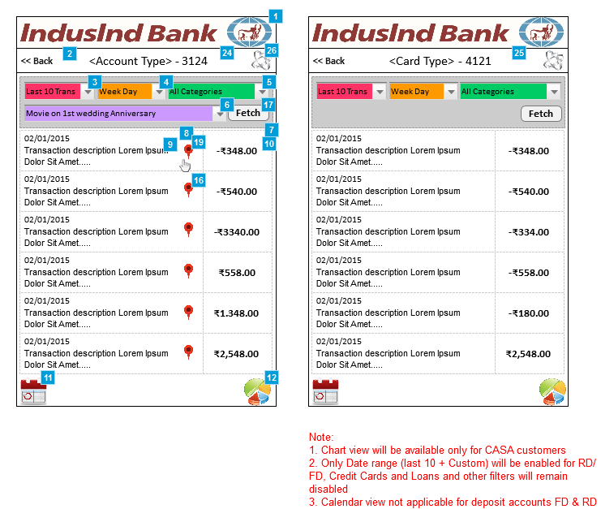

## Widgets Overview

| # | Item Name | Kony Widget Type | Description | Validation Rules | Action | Mandatory? |
| --- | --- | --- | --- | --- | --- | --- |
| 1 | Account Inquiry grid | Form | Account Inquiry grid |  |  |  |
| 2 | Back link | Link | Tapping will navigate to Account Overview page |  |  |  |
| 3 | Last 10 Transaction | List Box | Transaction options, Last 10 Trans Custom Fetch |  | Customer can change the selection Last 10 transactions will be displayed. (Transactions beyond 12 months will not be displayed)  In case of custom fetch, date range option will be displayed. |  |
| 4 | Date & Time option | List Box | Date & Time option which will display, Week Day Week Night Weekend Day Weekend Night  Default filter will be “All” and these values be provided from the host system as-is. |  | Customer can change the selection to filter the transactions by day-time. List of all transactions based on the selection will be displayed for the last 12 months with lazy loading effect |  |
| 5 | Transaction Categories | List Box | Transaction Categories - Bank assigned and pre-defined as provided by the backend |  | Customer can change the selection to filter the transactions by categories |  |
| 6 | Tags | List Box | List of all custom tags identified in the queried transactions provided by CBS will be populated. Default filter will be “All” and these values be provided from the host system as-is. |  | List of all transactions based on the selection will be displayed for the last 12 months with lazy loading |  |
| 7 | Transaction grid | Segment | Transaction grid that displays all transactions made on a chosen account/asset-type. At a time there will only be 10 transactions that will get displayed. | Maximum of 50 transactions can be displayed | Scroll to load more transactions |  |
| 8 | Transaction Date | Label | Transaction Date in DD/MM/YYYY format |  |  |  |
| 9 | Transaction Short Description | Label | Transaction Short Description - Fixed length |  |  |  |
| 10 | Transaction amount | Label | Transaction amount - debits will be displayed in red and all credits will be displayed in green color |  |  |  |
| 11 | Calendar view icon | Image | Calendar view icon |  | Tapping will take to calendar view of account inquiry |  |
| 12 | Chart view icon | Image | Chart view icon |  | Tapping will take to chart view of account inquiry |  |
| 16 | Tagging a transaction | Image | Customers can tag a transaction with their own comment |  | Tapping will open a popup where customer can enter the tag text for a transaction |  |
| 17 | Fetch button | Button | Fetch button to apply the filter criteria |  | Tapping will send the filter criteria to backend and will fetch the transactions based on the criteria |  |
| 19 | Custom Tagging | Image | Custom Tagging - customer can tag a particular transaction and once a transaction is tagged, the transaction cannot be tagged again. Default filter will be “All” and these values be provided from the host system as-is. |  |  |  |
| 24 | Page Header | Label | Page header of this page will be the concatenation of <Account Type> and last 4 digits of the account number. |  |  |  |
| 25 | Page Header | Label | Page header of this page will be the concatenation of <Account Type> and last 4 digits of the account number. |  |  |  |
| 26 | Icon for Payment & Transfer | Image | Icon for Payment & Transfer |  | Tapping will navigate to Icon for Payment & Transfer page |  |

Pre-condition

Customer has tapped on any of the accounts (or) on a Credit Card

Use Case - Main Flow

1. By default Last 10 Transactions will be displayed and all other 3 drop-downs will be inter-dependent.

2. Customers can opt to change the transactions from "Last 10 Trans" to "Custom Fetch" where a popup will appear as shown in the sample wireframe and customer can select the Start Date and End Date

3. Customers can select the Date-Time / Categories / Tags to filter the transactions listing

4. When the customer changes any of the item from Date-Time/Categories/Tags drop-down then all other drop-down values should set to "All" automatically. For example, if the customer selects "Weekend Day" then all other 2 drop-down (Categories and Tags) values should be "The last 10 transaction" / date range filter will remain same as chosen by the customer.

5. Then the customer will have to tap on "Fetch" button to filter the display of transactions

**Alternate Flow 1 - Calendar View:**

Customer can tap on the calendar icon which will take them to calendar view of the account inuiry (ledger)

**Alternate Flow 2 - Chart View:**

Customer can tap on the chart icon which will take them to chart view of the account inuiry (ledger)

Business Rules

1. Transaction beyond 12 months or 50 transaction will not be fetched irrespective on any filter

2. Any one from the following filter can be selected at a time

- Date/Time

- Categories

- Custom Tags

3. If any one of these is chosen the remaining two filters will be reset to “All”

4. Either Last 10 Transaction or the customer date rage will be a mandatory filter

5. Chart view will be available only for CASA accounts

6. Calendar view will not be available for deposit account like RD, FD

7. Only date range filter (last 10 transactions / custom fetch) will be available for accounts other than CASA, rest of the filters will remain disabled

8. Sorting will be in descending order of the transaction-date

9. Custom tagging on a particular transaction is allowed (only for CASA accounts) and once a transaction is tagged, the transaction can be tagged but the previous tag will be replaced.

10. Split, Quick and Scheduled payments (unrealized) will not be displayed in this page

Error Scenarios

1. If there are no transactions for the chosen date-range or for any of the filter criteria, then the app will display a message saying "There are no transactions to display" (or something similar)

2. If the server is down, the app will display appropriate error message

## Custom-Fetch

### State1

#### Wireframe

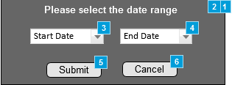

#### Widgets Overview

| # | Item Name | Kony Widget Type | Description | Validation Rules | Action | Mandatory? |
| --- | --- | --- | --- | --- | --- | --- |
| 1 | Date Selection Popup | Form | Date Selection Popup |  |  |  |
| 2 | Popup header | Label | Popup header |  |  |  |
| 3 | Start Date Selector | List Box | Start Date Selector | Start date to be within 1 year from current date | Tap to select a start date | Y |
| 4 | End Date Selector | List Box | End Date Selector | Max date range that can be selected at a time will be 3 months (92 days) End date to be greater that the start date | Tap to select an end date | Y |
| 5 | Submit button | Button | Submit button |  | Tapping will close the popup and will refresh the transactions listing as per the date range selected |  |
| 6 | Cancel button | Button | Cancel button |  | Tapping will close the popup and will retain the transactions listing as original |  |

## dp-Tagging

### State1

#### Wireframe

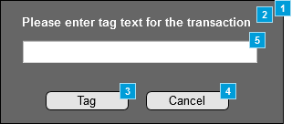

#### Widgets Overview

| # | Item Name | Kony Widget Type | Description | Validation Rules | Action | Mandatory? |
| --- | --- | --- | --- | --- | --- | --- |
| 1 | Tagging Popup | Form | Date Selection Popup |  |  |  |
| 2 | Popup header | Label | Popup header |  |  |  |
| 3 | Tag button | Button | Tag button |  | Tapping will save the tag and will close the popup window and will refresh the transaction listing as per the tag selected |  |
| 4 | Cancel button | Button | Cancel button |  | Tapping will close the popup and will retain the transactions listing as original |  |
| 5 | Tag text | Text Box | Tag text - custom text as entered by customer | Min - 1 char Max - 15 chars |  | Y |

# Account Inquiry - Calendar View

Page Overview

This is the calendar view of Account Inquiry page where all the transactions will be displayed in a symbolic fashion on dates wherever there are transactions available. The transactions will be color coded - for example, all expenses (debits) will be in red, all deposits/funds-received (credits) will appear in green, all scheduled transfers will appear in yellow and so on).

## Wireframe

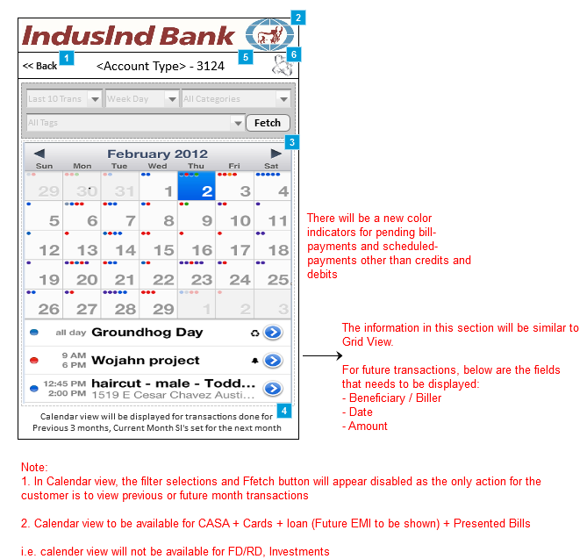

## Widgets Overview

| # | Item Name | Kony Widget Type | Description | Validation Rules | Action | Mandatory? |
| --- | --- | --- | --- | --- | --- | --- |
| 1 | Back link | Link | Back link |  | Tapping will navigate to Account Overview page |  |
| 2 | Account Inquiry - Calendar view | Form | Account Inquiry - Calendar view |  |  |  |
| 3 | Calendar view | Calendar | Customer can navigate the calendar back upto 3 months from current month and forth upt o 1 future month from current month  Future month will display the scheduled payment and pending bills  In case of future month calendar view, all filters will be disabled |  | Tapping Left and Right arrows will move the calendar month back and forth |  |
| 4 | Instruction label | Label | Instruction label |  |  |  |
| 5 | Page Header | Label | Page header of this page will be the concatenation of <Account Type> and last 4 digits of the account number. |  |  |  |
| 6 | Icon for Payment & Transfer | Image | Icon for Payment & Transfer |  | Tapping will navigate to Icon for Payment & Transfer page |  |

Pre-condition

Customer has tapped on the calendar icon (image) from Account Inquiry page.

Use Case - Main Flow

1. Customers cannot see the transactions based on any of the filters because they will appear disabled for calendar view.

2. Tapping any of the day in calendar will show the transactions performed in that day just undereneath the calendar as shown in the sample wireframe above

**Exception Flow:**

If there are no transactions for the chosen date then there will be no color-codes and the date will not be clickable.

Business Rules

1. The transactions should be color coded: Red = spent/debit, Green = deposit/credit

2. Customer can navigate the calendar back upto 3 months from current month and forth upt o 1 future month from current month

3. Future month will display the scheduled payment and pending bills

4. Color code will represent each transaction i.e. if there are two credit transaction, the date will have two green indicators

5. Depending upon UI feasibility a limited number of indicator will be displayed on a date. However the entire transaction will be listed on tap of a particular date up to a max of 50 transaction

6. Sorting will be in descending order of the transaction-date

7. By default the current month will appear on screen load

8. For future transaction beneficiary / Biller, Date and amount will be displayed

Error Scenarios

1. If there are no transactions on a particulate date appropriate message will be displayed in the transaction listing

2. If the server is down, the app will display appropriate message

# Account Inquiry - Chart View

Page Overview

This is the chart view of Account Inquiry page where all the transactions will be displayed based on the filter that was applied either by date-time spends or based on the category.

## Wireframe

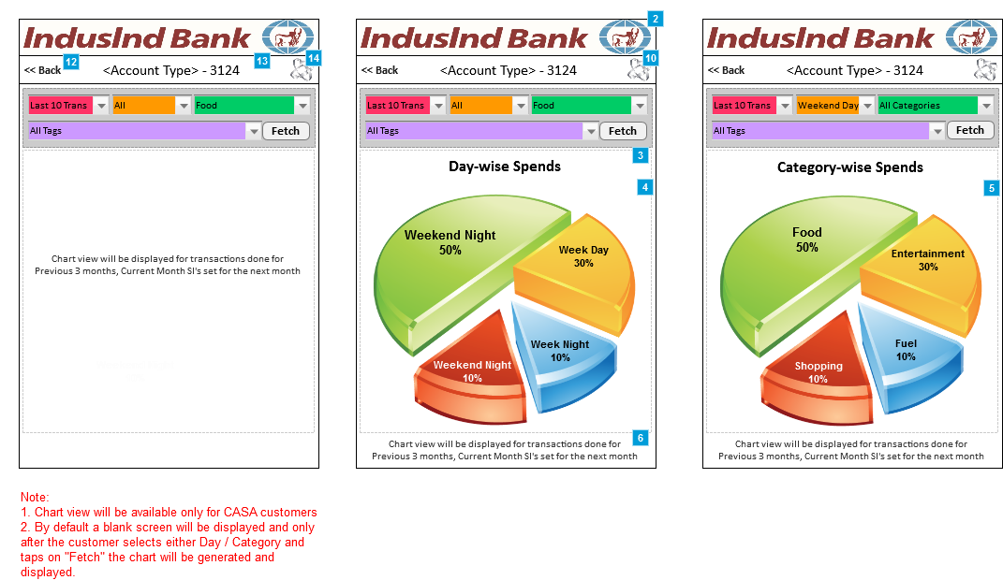

## Widgets Overview

| # | Item Name | Kony Widget Type | Description | Validation Rules | Action | Mandatory? |
| --- | --- | --- | --- | --- | --- | --- |
| 2 | Account Inquiry - Chart view | Image | Account Inquiry - Chart view |  |  |  |
| 3 | Page title | Label | Page title |  |  |  |
| 4 | Chart by Day and Time of spends | Chart | Chart by Day and Time of spends |  |  |  |
| 5 | Chart by Category of spends | Chart | Chart by Category of spends |  |  |  |
| 6 | Instruction label | Label | Instruction label |  |  |  |
| 10 | Icon for Payment & Transfer | Image | Icon for Payment & Transfer |  | Tapping will navigate to Icon for Payment & Transfer page |  |
| 12 | Back link | Link | Back link |  | Tapping will navigate to Account Overview pageresume to the same screen |  |
| 13 | Page Header | Label | Page header of this page will be the concatenation of <Account Type> and last 4 digits of the account number. |  |  |  |
| 14 | Icon for Payment & Transfer | Image | Icon for Payment & Transfer |  | Tapping will navigate to Icon for Payment & Transfer page |  |

Pre-condition

Customer has tapped on the chart icon (image) from Account Inquiry page.

Use Case - Main Flow

1. By default a blank screen will be displayed and only after the customer selects either Day / Category and taps on "Fetch" the chart will be generated and displayed.

2. Customers can see the transactions based on any of the filters (last 10/custom fetch, day-time, categories but not tags).

3. When the customer changes any of the item from a drop-down then all other (Categories & Tags) drop-down values will be set to "All" automatically. For example, if the customer selects "Weekend Day" then all other drop-down values will reset to "The last 10 transaction" /date range filter will remain same as chosen by the customer

4. Then the customer will have to tap on "Fetch" button to filter the display of transactions

Business Rules

1. Based on the filter applied, the chart and percentage will change

2. Custom tag filter will not be available for chart view

3. Last 10 transaction / Date range will be a mandatory filter

4. By default All will be selected when the page loads.

Error Scenarios

1. If there are no transactions for the chosen date-range or for any of the filter criteria, then the app will display a message saying "There are no transactions to display" (or something similar)

2. If the server is down, the app will display appropriate error message